You will find activities required for FT3 refresh are listed below:-

**Pre-Refresh Activities: -**

Salesforce Org Refresh Activities: -

Template and associated object

TemplateFT3PartialCopySandbox

NE__Lov__c

**NE__Map__c**

NE__MapObject__c

NE__MapObjectItem__c

NE__MapObjectItemAttribute__c

The pre refresh activities will include backup of metadata component with the help of OwnBackup tool and manual steps.

**OwnBackup Activities: -**

1. Named Credentials (Constraint - Password not possible to captured)

2. Auth-Provider (Constraint - Consumer Secret not possible to captured)

3. Connected Apps (Constraint - Only Callback URL are possible to capture)

4. Custom Labels

5. Custom Setting > can’t be fetched by VSCode Downloaded by Workbench

6. Custom Metadata > can not be fetched by VSCode Downloaded by Workbench

7. External Data Source

8. Remote Site Setting

**Manual Activities: -**

1. Outbound Messages

2. Named Credential User/Password required from respective Application Owner

3. Auth Provider User/Password required from respective Application Owner

4. Auth Provider Consumer Key/Secret should be captured manually

5. Capture Org and community endpoint along with ORGID and instance name

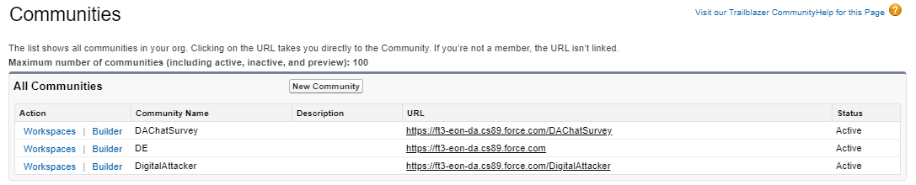

|  |  |  |  |  |
| --- | --- | --- | --- | --- |
| **Action** | **Community Name** | **Description** | **URL** | **Status** |
| [Workspaces](https://eon--ft3.my.salesforce.com/servlet/networks/switch?networkId=0DB1v00000010XT&startURL=%2FcommunitySetup%2FcwApp.app%23%2Fc%2Fhome) | [Builder](https://eon--ft3.my.salesforce.com/sfsites/picasso/core/config/commeditor.jsp?exitURL=https%3A%2F%2Feon--ft3.my.salesforce.com%2Fservlet%2Fnetworks%2Fswitch%3FnetworkId%3D0DB1v00000010XT%26startURL%3D%252FcommunitySetup%252FcwApp.app%2523%252Fc%252Fhome&siteId=0DM1v0000000qk9) | DAChatSurvey |  | [https://ft3-eon-da.cs89.force.com/DAChatSurvey](https://eon--ft3.my.salesforce.com/servlet/networks/switch?networkId=0DB1v00000010XT) | Active |
| [Workspaces](https://eon--ft3.my.salesforce.com/servlet/networks/switch?networkId=0DB0Y000000g1O8&startURL=%2FcommunitySetup%2FcwApp.app%23%2Fc%2Fhome) | [Builder](https://eon--ft3.my.salesforce.com/sfsites/picasso/core/config/commeditor.jsp?exitURL=https%3A%2F%2Feon--ft3.my.salesforce.com%2Fservlet%2Fnetworks%2Fswitch%3FnetworkId%3D0DB0Y000000g1O8%26startURL%3D%252FcommunitySetup%252FcwApp.app%2523%252Fc%252Fhome&siteId=0DM0Y000000QI2K) | DE |  | [https://ft3-eon-da.cs89.force.com](https://eon--ft3.my.salesforce.com/servlet/networks/switch?networkId=0DB0Y000000g1O8) | Active |
| [Workspaces](https://eon--ft3.my.salesforce.com/servlet/networks/switch?networkId=0DB0Y000000g1Ml&startURL=%2FcommunitySetup%2FcwApp.app%23%2Fc%2Fhome) | [Builder](https://eon--ft3.my.salesforce.com/sfsites/picasso/core/config/commeditor.jsp?exitURL=https%3A%2F%2Feon--ft3.my.salesforce.com%2Fservlet%2Fnetworks%2Fswitch%3FnetworkId%3D0DB0Y000000g1Ml%26startURL%3D%252FcommunitySetup%252FcwApp.app%2523%252Fc%252Fhome&siteId=0DM0Y000000QHwG) | DigitalAttacker |  | [https://ft3-eon-da.cs89.force.com/DigitalAttacker](https://eon--ft3.my.salesforce.com/servlet/networks/switch?networkId=0DB0Y000000g1Ml) | Active |

**Sandbox Information**

|  |  |
| --- | --- |
| **Sandbox Name** | FT3 |
| **Description** | Partial Copy Sanbox created on 26 June 2020 |
| **Sandbox License** | Partial Copy |
| **Status** | Completed |
| **Location** | CS89 |
| **Current Org Id** | 00D0E0000002Iog |
| **Completed On** | 27.06.2020 02:30 |
| **Created By** | [Nikhilesh Kumar](javascript:srcUp('%2F0051v000006oyzd%3Fisdtp%3Dp1%26isUserEntityOverride%3D1%26noredirect%3D1');) |
| **Created Date** | 26.06.2020 13:25 |
| **Last Refresh Request By** | [Nikhilesh Kumar](javascript:srcUp('%2F0051v000006oyzd%3Fisdtp%3Dp1%26isUserEntityOverride%3D1%26noredirect%3D1');) |
| **Last Refresh Request Date** | 26.06.2020 13:25 |

**Next Refresh Available**

Now

**Sandbox Options**

|  |  |
| --- | --- |
|  |  |
| **Is Sandstorm Copy** |  |
| **Sandbox Template Used** | TemplateFT3PartialCopySandbox |
| **Refresh Interval** | 0 Day |
| **Next Refresh Available** | Now |
| **Auto Activate** |  |
| **On Demand Refresh** |  |
| **Apex Class** |  |

***User Backup before Refresh (Performed by DIAM Team)***

*1. Backup of all user (only internal)*

*2. Capture user details along with Permission Set*

*3. Extract active records from User & Permission Set Assignment object*

**Post Refresh Activities: -**

1. All Sanitization activities Required (Replace all production reference either with Test or QA)

2. Removal of SFMC prod references from Org

3. Re-integrate with correct Username/Password if both known (Either user or password or both unknown - Put test user/test password)

4. Bit2win Configuration in SF after Heroku setup (Performed by Nikhilesh after document shared by Bit2win team)

5. After refresh share Orgid, Org URL to Bit2win team and activate Bit2win team users in Org

6.  New endpoint, Integration user details will be provided to respective application team for re-integration (All applications)

7. Chatbot, Live Agent, PureConnect development team support will be needed for re-integration

8. Gabi test, Contract ids data to be imported from Old Org to New Org using OwnbBackup/Dataloader, details are included in an email. (Activity performed by Ram)